**Project Design Phase-II**

**TechnologyStack(Architecture&Stack)**

|  |  |
| --- | --- |
| Date | 12October2022 |
| TeamID | PNT2022TMID51451 |
| ProjectName | Project–**Real-TimeCommunicationSystem Powered**  **By AI For Specially Abled** |
| MaximumMarks | 4Marks |

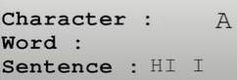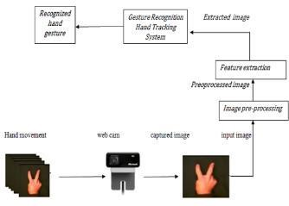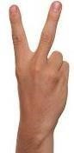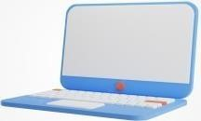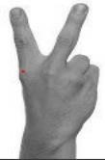

**Technical**

**Architecture:**

**ObtainOutputtextinthe form**

**of speech**

**Output**

**text**

**End**

**-**

**user**

**User interface**

**Capturethesign**

**within**

**ROI**

**Backgroundispopped and**

**original sign is**

**extracted**

**Gaussian**

**blurfilterto**

**get outline**

**Original**

**Gray**

**-**

**scale**

**Table-1:Components&Technologies:**

|  |  |  |  |  |  |  |
| --- | --- | --- | --- | --- | --- | --- |
| **S.No** | **Component** | **Description** | | | | **Technology** |
| 1. | UserInterface | Howuserinteractswithapplicationi.e**.Desktopusage and clicking the concerned app.** | | | | HTML,CSS,JavaScriptand Angular  JS |
| 2. | ApplicationLogic-1 | • Camera**detectsthesignshownbytheuser**. • Captures**thesignwithinROI.** | | | | **Adaboostfacedetectorisused**todifferentiate between faces and hand as both involves similar skin-colour. |
| 3. | ApplicationLogic-2 | • **Backgroundispoppedandoriginalsignisextracted**. | | | | Bydefault,Originalimagecapturedisconverted into Gray-scale image. |
| 4. | ApplicationLogic-3 | • Extractthe**edgesofthegray-scaleimage**. | | | | **Apply Gaussian-blurfilterand threshold to the frametakenwithOpenCV**togettheprocessed image after feature-extraction. |
| 5. | ApplicationLogic-4 | • Convertthe**outputtextintospeech** | | | | **TheFinaltextobtainedisconvertedtospeech using the speech assistant implemented ,** whichinturnproducesoundfromspeaker. |
| 6. | Database | • **BinaryLargeObject(BLOB)**isthedatatypeusedtostorethe images in the dataset. | | | | **MySQLdatabase** isused. |
| • | /etc/mysql/my.cnfisthedefaultconfiguration/directoriesforMYS | |  |
| QL that is used. |  |
| 7. | FileStorage | • **CreateaBLOBcolumnfortheimagefiles,whethertheybe JPEG,PNG,PSD**orwhatever,andthen loadtheimages into thetable/column,createdforthem. | | | | **LocalFilesystem**isusedforstoringthe images. |
| 8. | MachineLearningModel | **Allowstheusertofeed acomputeralgorithmanimmenseamountof data**  **and have the computer analyze and make data-driven recommendations** and decisions based on only the input data | | | | **SupervisedandUnsupervisedlearningmodel etc**. |

**Table-2:ApplicationCharacteristics:**

|  |  |  |  |
| --- | --- | --- | --- |
| **S.No** | **Characteristics** | **Description** | **Technology** |
| 1. | Open-SourceFrameworks | * **Palmdetector**operatesonfullimagesandoutputsan oriented bounding box. * **Handlandmark**takesthecroppedimagedefinedbythepalm detector and returns 3D hand key points. * **Gesturerecognizer**thenclassifiesthepreviouslycomputed keypointconfigurationintoadiscretesetofgestures | **Media Pipe Framework is used**. Within this framework,thepipelineisbuiltasadirected graph of modular components. |
| 2. | ScalableArchitecture | * It’saThree–TierArchitecturecomprisesthefollowing technology,   Convolutionalneuralnetworkcanbescaledinthreedimensions:*depth, width,resolution*.   * **Depth**ofthenetworkcorrespondstothenumberoflayersina network. * **Width**isassociatedwiththenumberofneuronsinalayer. * **Resolution**istheimageresolutionthatisbeingpassedtoCNN. **Increasingthedepth**,bystackingmoreconvolutionallayers, allows the network to learn **more complex features**. | **ConvolutionNeuralNetworksisused.** |
| 3. | Availability | Hand gestures are **the natural way of interactions when one personiscommunicatingwithoneanother**andthereforehand movements can be treated as a non verbal form of communication. Hand gesture recognition is a process of understanding and classifying meaningful movements by the humanhands | **CNN,MediaPipe,Gaussianblurfilter,**  **MachinelearningmodelsalongwithSpeech assistant** is used. |